Term Project Proposal: Bio Beat

Group D
Group Members:
Abdullah Adeeb - 100833573
Drew Gascoigne – 100827090
Tejas Patil - 100823713
Zachary Cousins - 100827542
Course Code: SYSC 3010
Date: October 9, 2013
Motivation
The motivation behind the Bio Beat project is to find a way to play music based on the body’s vitals, heart rate and temperature. The idea is to assist the user in their daily lives by playing music based on what they are doing. Bio Beat would be a personal playlist creator so that the user does not have to spend hours making different playlists depending on the mood, the Bio Beat would do that for them. This gives the user more time to enjoy the music and enjoy their day.
Objectives
Bio Beat is a device that will take the users heart rate and temperature and play music based on these data. This is to help set the mood of the user whether they are trying to relax or have a good time.
Goals
The goal is to have a Raspberry Pi properly retrieving temperature and heart rate. This will be done using the I/O ports on the Pi and converting the analog data from the sensors to digital data so it can be properly interpreted. Then an algorithm in the server would have to be created to select a song or playlist based on the data. From that point it’s just a matter of selecting from a database of songs and telling the other Pi what to play.
Scope
The project scope consists of a few constraints for the project. One of the notable ones is that the user’s pulse will have to be monitored real-time. In order to do so, the user will have to attach a device to detect their pulse. This can be an inconvenience but if implemented properly a solution can be found to cause the least amount of inconvenience to the user. Furthermore, if the pulse monitor is disconnected an alternate solution to gather pulse data needs to be implemented. A proposed solution is to notify the user that the pulse device is disconnected.

In addition, the temperature of the room could be misrepresented if the device is placed near a dehumidifier or a heater. Initially the project will have to be implemented for home use only since there a number of devices being used to ensure that the communication, GUI, temperature sensing, and playlist creation is appropriately handled. But, outside the scope of this project it is possible to have a smart-phone application to do the above functions in a more compact manner.

Proposed Solution
Pi Board 1:
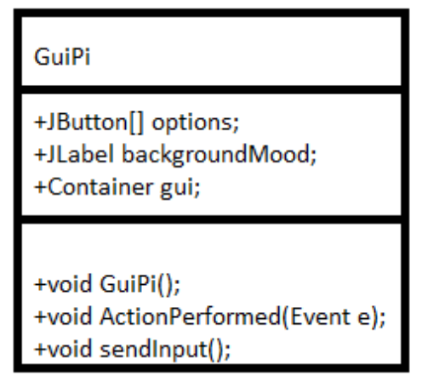
Pi Board 2:

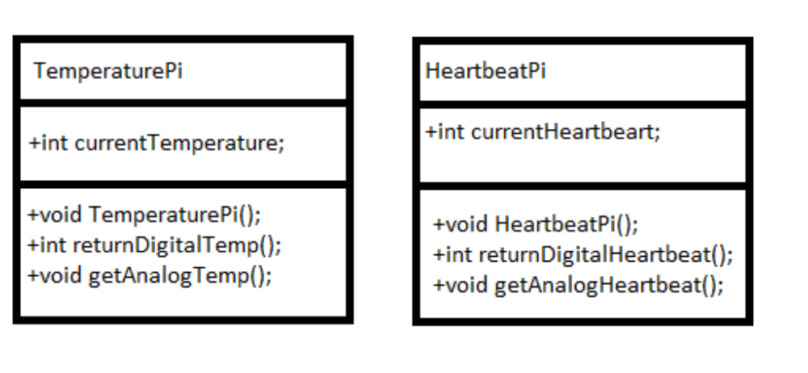
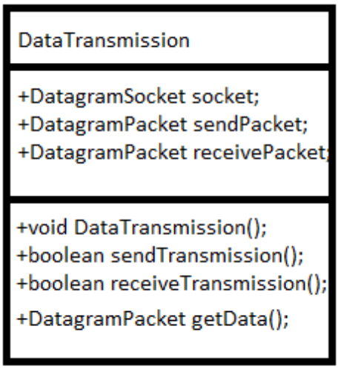

Pi Board 3:
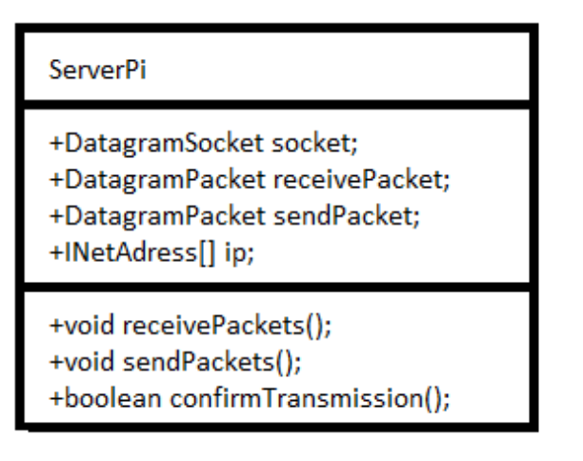
Pi Board 4:
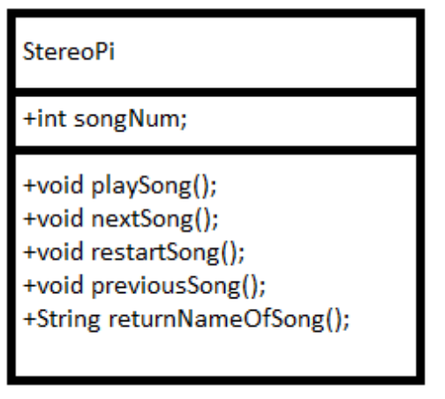

This is a small overview of the plan to implement the project using four Raspberry Pi boards. The above consists of UML class diagrams that are partially completed with most of the planned classes, methods, and variables. Over the course of the iterative development process many more classes and methods will be added. However, the above will act as the skeleton for the project.

Project Schedule
Task Description | Duration  (in weeks) | Preparation start | Due Date
Design Review Presentation | 1 | Week of October 14, 2013 | 21 October 2013
Demonstration of tested requirement | 3.5 | Week of October 21, 2013 | 14 November 2013
Code Review Demonstration | 1 | Week of November 14, 2013 | 18 November 2013
Final Demonstration | 2.5 | Week of November 18, 2013 | 4 December 2013

Equipment required
The list of items required is the following:
- An 8-channel 10-bit Analog to Digital converter
- Temperature sensor
- Pulse Sensor
Here is where the items can be purchased:
- http://www.adafruit.com/products/856
- https://www.sparkfun.com/products/10988
- http://pulsesensor.myshopify.com/products/pulse-sensor-amped

